Chapter 10, Problem 27.

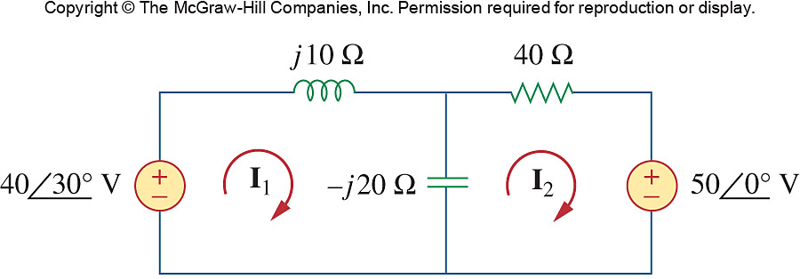
Using mesh analysis, find I₁ and I₂ in the circuit of Fig. 10.75.

Figure 10.75
For Prob. 10.27.

